**HW9**

**Data Analysis**

1. **List the employee number, last name, first name, sex, and salary of each employee.**

select

e.emp_no,

e.last_name,

e.first_name,

e.sex,

s.salary

from

employees as e

join salaries as s on e.emp_no = s.emp_no

order by

s.salary desc

limit 10

1. **List the first name, last name, and hire date for the employees who were hired in 1986.**

select

e.first_name,

e.last_name,

e.hire_date

from

employees as e

where

hire_date between '1986-01-01' and '1986-12-31'

order by

e.hire_date asc

limit 10

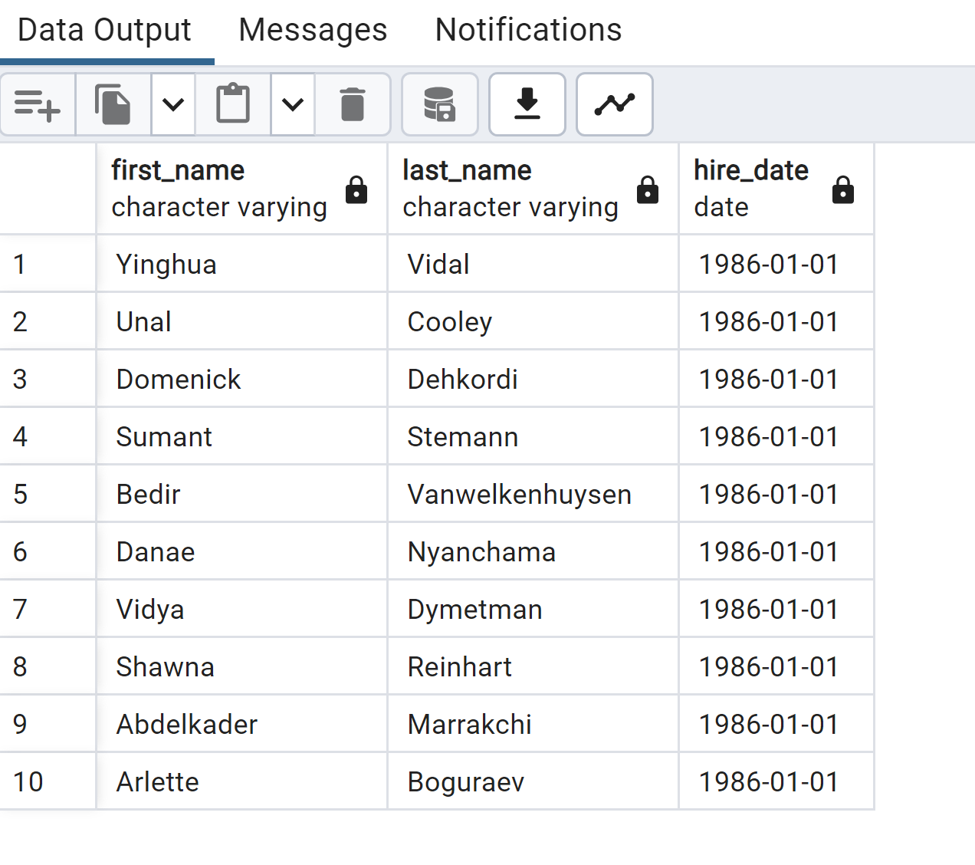

1. **List the manager of each department along with their department number, department name, employee number, last name, and first name**.

select

departments.dept_no,

departments.dept_name,

dept_manager.emp_no,

employees.last_name,

employees.first_name

from

departments

join dept_manager

on departments.dept_no = dept_manager.dept_no

join employees

on dept_manager.emp_no = employees.emp_no;

1. **List the department number for each employee along with that employee’s employee number, last name, first name, and department name.**

select

dept_emp.dept_no,

dept_emp.emp_no,

employees.last_name,

employees.first_name,

departments.dept_name

from

dept_emp

join employees

on dept_emp.emp_no = employees.emp_no

join departments

on departments.dept_no = dept_emp.dept_no;

1. **List first name, last name, and sex of each employee whose first name is Hercules and whose last name begins with the letter B.**

select

employees.first_name,

employees.last_name,

employees.sex

from

employees

where

employees.first_name = 'Hercules' and employees.last_name like 'B%';

1. **List each employee in the Sales department, including their employee number, last name, and first name.**

select

dept_emp.emp_no,

employees.last_name,

employees.first_name,

departments.dept_name

from

dept_emp

join employees

on dept_emp.emp_no = employees.emp_no

join departments

on departments.dept_no = dept_emp.dept_no

where

departments.dept_name = 'Sales';

1. List each employee in the Sales and Development departments, including their employee number, last name, first name, and department name.

select

dept_emp.emp_no,

employees.last_name,

employees.first_name,

departments.dept_name

from

dept_emp

join employees

on dept_emp.emp_no = employees.emp_no

join departments

on departments.dept_no = dept_emp.dept_no

where

departments.dept_name = 'Sales' or departments.dept_name = 'Development';

1. A screenshot of a computer

   Description automatically generated**List the frequency counts, in descending order, of all the employee last names (that is, how many employees share each last name).**

select

last_name,

count(last_name) as "frequency"

from

employees

group by

last_name

order by

count(last_name) desc;